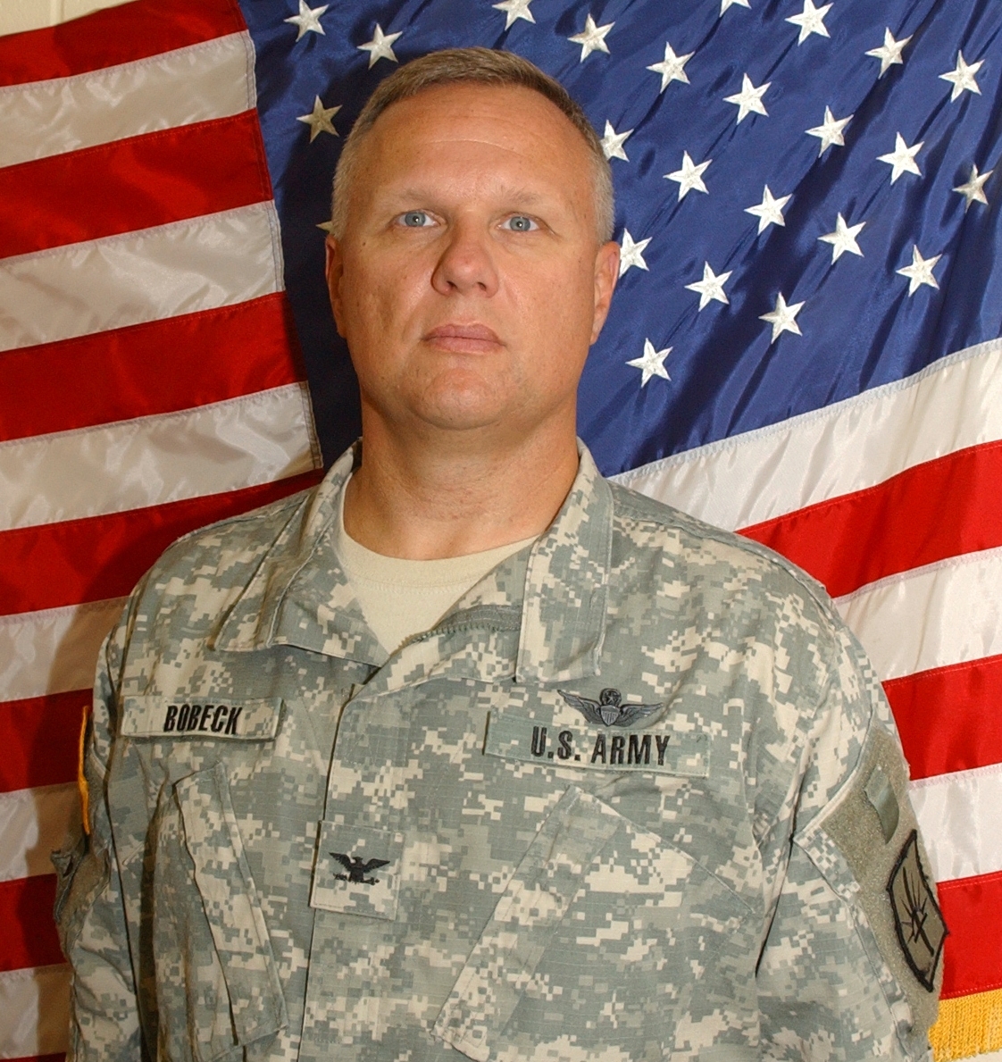

Colonel Michael E. Bobeck was born in Buffalo, New York. He enlisted in the New York Army National Guard in 1979 as an infantryman and was initially assigned to the 1-174th Infantry in Tonawanda, New York. Colonel Bobeck enrolled in the Reserve Officer Training Corps (ROTC) program at Canisius College and was commissioned in 1983 as a second lieutenant in the infantry and went on to active duty as an aviation officer in July 1984.
He was initially assigned to the 3rd Armored Cavalry Regiment as an Aeroscout platoon leader at Fort Bliss, Texas. He graduated from the aviation officer advanced course in 1988 and attended the aviation maintenance and maintenance test pilot courses for the AH-1 Cobra. He was next assigned to the 10th Mountain Division serving as Aviation Intermediate Maintenance (AVIM) production control officer and Commander, D Troop 3/17th Cavalry. He attended the CH-47 aircraft qualification course and maintenance test pilot course in March 1992 and was selected for the elite 160th Special Operations Aviation Regiment (SOAR) where he was assigned to 3rd Battalion, 160th SOAR at Hunter Army Air Field, Georgia and served as a maintenance officer, Battalion S4, and finally Commander C Company, 3/160th.
Colonel Bobeck left active duty in February 1997 to become Commander, Army Aviation Support Facility #2, New York Army National Guard in Rochester, New York. He served as the Battalion Executive Officer of the 1/142nd Attack Battalion and was selected to command the 1/142nd AVIM Battalion as the Battalion was identified for mobilization and deployment to the Iraqi theater in support of Operation Iraqi Freedom in Jan 2004-Jan2005. Colonel Bobeck became the State Army Aviation Officer in January 2001.

He is a graduate of the U.S. Army War College and his awards include the Bronze Star, Meritorious Service Medal with 2 Oak Leaf Clusters, and the Air Medal.

He is married to the former Kim M Davis and they have 3 girls, Samantha 18, Kelsey 16, and Jessica 15.

